**DEVICE TO PROGRAM**

* Buy the PSOC 5LP(Availe in: <http://www.cypress.com/documentation/development-kitsboards/cy8ckit-059-psoc-5lp-prototyping-kit-onboard-programmer-and> ) or KitProg (Availe in: <http://www.cypress.com/documentation/development-kitsboards/cy8ckit-002-psoc-miniprog3-program-and-debug-kit> ) for PSOC chip.
* Cut the PCB destined (PSOC 5 LP) for the USB connection (If you bought the MiniProg3 this step is not necessary).

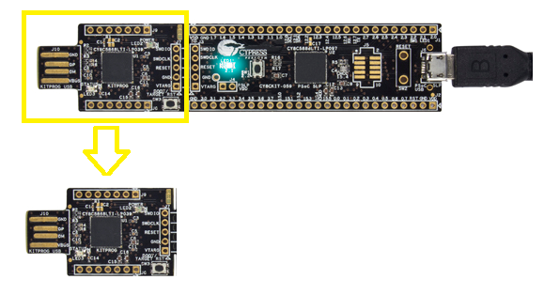

* Weld the terminals as shown in the figure with a UTP Cable.

